Type of the Paper (Article)
Research on DRT Informed Diffusion Equivalent Circuit Model
Miguel Ferreira ¹, Georgios I. Orfanoudakis ² and Suleiman M. Sharkh ^{3,}*
Academic Editor: Firstname Lastname
Received: date
Revised: date
Accepted: date
Published: date
Citation: To be added by editorial staff during production.
Copyright: © 2026 by the authors. Submitted for possible open access publication under the terms and conditions of the Creative Commons Attribution (CC BY) license (https://creativecommons.org/licenses/by/4.0/).
¹ Mechanical Engineering, University of Southampton, SO17 1UA, UK; mf8g22@soton.ac.uk
² Department of Electrical and Computer Engineering, Hellenic Mediterranean University (HMU), Estavromenos, Heraklion GR-71410, Crete, Greece; gorfas@hmu.gr
³ Mechanical Engineering, University of Southampton, SO17 1UA, UK; S.M.Sharkh@soton.ac.uk
* Correspondence: S.M.Sharkh@soton.ac.uk
Abstract
As demand grows for high-capacity and efficient energy storage systems for electric vehicles and sustainable technologies, accurate determination of battery State of Charge (SoC) is becoming increasingly important. This work explores an alternative method for estimating the SoC using Electrochemical Impedance Spectroscopy (EIS) and the Distribution of Relaxation Times (DRT) methods. The diffusion peak and diffusion time constant calculated using the DRT for EFEST 18650 cells were found to decrease as SoC increased up to 60% SoC beyond which their trend did not exhibit significant change. An open circuit voltage (OCV)-based SOC estimation method was explored using the DRT results to deduce the form of an appropriate equivalent circuit model (ECM) including diffusion elements. The OCV-based estimation method was able to predict the SoC accurately down to an average difference of 0.59% with the greatest difference being 2.46%.
Keywords: Lithium-ion; Battery Modelling; Electrochemical Impedance Spectroscopy (EIS); SoC; Distribution of Relaxation Times (DRT); Equivalent Circuit Model (ECM)

1. Introduction
The State of Charge (SoC) is an important property computed by a Battery Management System (BMS) to manage it effectively. Several methods exist for estimating the SoC of a battery including lookup table approaches, ampere-hour integration, and model-based estimation techniques. The lookup table method typically correlates SoC with battery parameters such as open-circuit voltage (OCV) or impedance. However, accurate measurement of the OCV requires the battery to rest for long periods of time, often several hours, rendering this method unsuitable for online real time estimation.
The ampere-hour integration method estimates SoC by integrating the current over time starting from a known charge. This method is effective during standard operation; however, it has major limitations. In addition to requiring precise knowledge of an initial SoC, which is challenging as the capacity depends on temperature, past usage and aging, this method suffers from sensitivity due to integration drift caused by sensor offsets, which require regular resetting.
Model-based estimation techniques often employ equivalent circuit models, Kalman filters (KF), or machine learning algorithms, aimed at determining crucial BMS outputs such as SoC, SoH, available power and cell imbalance [1].
The use of Kalman Filters and the Extended Kalman Filter (EKF) for real-time SoC estimation were introduced by Plett in [2]. Plett progressively develops increasingly sophisticated battery models including Coulomb counting, ohmic resistance, OCV-SOC relationship and hysteresis, among others in [3]. Hysteresis being of particular importance in the low temperature regions. It was found that additional enhanced self-correcting (ESC) filter states improve accuracy but increase computational complexity. Plett extends this methodology to estimate BMS parameters using a Dual Kalman Filter strategy to estimate model parameters such as capacity and resistance values in [4].
Chao et al. build on Plett’s work, recognizing that SoC and capacity estimation have different time scales and exploit this to produce a multiscale EKF leading to higher accuracies and lower computational costs. Over the full test conducted, the dual Kalman EKF produced 6.57% while the multiscale produced 3.93% [5].
Campestrini et al. provide a comparative study between 18 different KF algorithms, such as Extended Kalman Filter (EKF), Unscented Kalman Filter (UKF) and Dual Filtering techniques. Overall improved accuracy was found with the two-RC model with substantial sensitivity to incorrect ECM parameters, eased by the use of Dual Filtering. Implying that errors in SoC estimation when using Kalman filters tend to arise from inaccurate models [6].
The most robust machine learning models, incorporate EIS or DRT data to estimate SoC or SoH, as demonstrated by Messing et al., where EIS data is used in an ML model to estimate SoC instead of traditional current and voltage data [7].
Other SoC estimation models include a mixture of offline and online estimation techniques often employing machine learning models, such as Yang et al. where a Long Short-Term Memory (LSTM) and Recurrent Neural Networks (RNN) models are used in conjunction with an Unscented Kalman Filter (UKF). The LSTM-RNN model alone yields a Mean Absolute Error (MAE) of 1.6%, reducing to within 1% when the UKF is applied, a substantial performance increase when compared to traditional ML or Kalman only approaches, although presenting higher computational complexity [8].
Although equivalent circuit models (ECMs) can provide accurate predictions, they often require initial parameter guesses and a priori assumptions, which need to be tuned to match the data of the battery [9]. Often a typical second order Thevenin equivalent circuit offers simplicity and accuracy when estimating SoC as found by Pang et al, particularly looking to model charge transfer and polarization within the battery [10]. However, it fails to represent diffusion.
Modelling of the diffusion phenomenon within the 2RC ECM framework is presented by J. Estaller et al, where the low frequency behaviour of various cell chemistries were modelled using a semi-infinite Warburg term. The authors present the success of integrating diffusion elements into ECM, better capturing cell characteristics, without computing properties such as SoC, or SoH [11].
Iurilli et al. published a method for estimating the SoC of commercial lithium-ion batteries using the distribution of relaxation times (DRT) produced using EIS data. They documented the effect of varying the SoC on DRT peaks corresponding to certain electrochemical processes; SoC determination was achieved by estimating the OCV from impedance data using an extended Kalman fliter (EKF) estimation algorithm. In the proposed ECM the authors directly extract ECM parameters from the DRT and utilise 5RC branches in series with a capacitor to model diffusion [12].
Due to its non-destructive nature and ability to produce comprehensive data, electrochemical impedance spectroscopy (EIS) has been explored by various authors in recent years as a potential way of determining SoC. As demonstrated by Liu et al. and Wahyudi et al. online application of EIS is possible using exiting power electronic interfaces or BMS cell equalization circuits, providing close agreement and extending EIS as a possible technique for online SoC determination [13],[14].
An important theme within the literature remains the deployment of accurate, yet computationally inexpensive models. A significant source of error when deployment Kalman strategies, remains incorrect model parameters and inaccurate ECMs. While machine learning models, despite achieving high accuracy can be computationally expensive.
Traditional ECM fitting struggles to account for changes in parameters due to aging and temperature. Using DRT informed ECM modelling, this paper proposes ECM fitting at each stage with on-board EIS to update parameters and reduce residuals. This paper makes the following novel contributions: 1) It examines how the metrics of the diffusion process, the peak and time constant, can be extracted from the DRT and correlated directly with the SoC, demonstrating a need for diffusion to be modelled within an ECM 2) Additionally, an OCV-based SOC estimation method using the DRT results was developed and used deduce the form and parameter values of an appropriate equivalent circuit model (ECM) including diffusion elements, and a comparison study is presented between the proposed 5RC branch model and the traditional 2RC model.

2. Methodology
An IVIUM STAT system as shown in Figure 1 was used to perform EIS measurement spanning the useful spectrum of a battery capturing the contribution of various electrochemical processes occurring within the battery at each frequency. For lithium-ion batteries this spectrum typically ranges from 0.01-10,000 Hz; however, in this study a range of 0.01-1,000 Hz was utilized, neglecting the effects of inductance. From the impedance data the DRT method is used to uncover the characteristic time constants linked to each major electrochemical processes within the battery, informing ECM modelling decisions.

2.1. Experimental Procedure
The IVIUM STAT, Figure 1, was used to discharge the battery at a constant rate to a predetermined SoC calculated as in Eq. (1):
$$\begin{aligned}SoC={SoC}_{0}+\frac{1}{C_{max}}\int_{0}^{t}{i\left(τ\right)dτ}\#\left(1\right)\end{aligned}$$
Where ${SoC}_{0}$ is the initial SoC, $C_{max}$ the maximum capacity of the battery in mAh, and $i(τ)$ the discharge current in mA over time $τ$ until time $t$ [15].
The maximum capacity of the battery was determined by fully charging to a voltage of 4.1 V and performing a full discharge cycle down to 2.75 V. These values are kept within the operating voltage of the battery avoiding damage from overcharging and deep discharge [16].
The current-time graph for this process is integrated to determine the battery capacity of 4 different cells at different states of health (SoH); 100.0%, 88.6%, 85.9%, 83.3%, calculated as in Eq. (2) [17]:
$$\begin{aligned}SoH=\frac{C_{max}}{C_{i}}\#\left(2\right)\end{aligned}$$
Where $C_{i}$ is the initial battery capacity (2100mAh) [18]. EIS is carried out at various SoCs with a 0.1 C AC perturbation signal ($i=210 mA$), Figure 2,a displays the voltage against SoC for the charging and discharging process as well as the OCV-SOC relationship. Figure 2,b displays the Nyquist plot at 70% SoC as SoH varies.
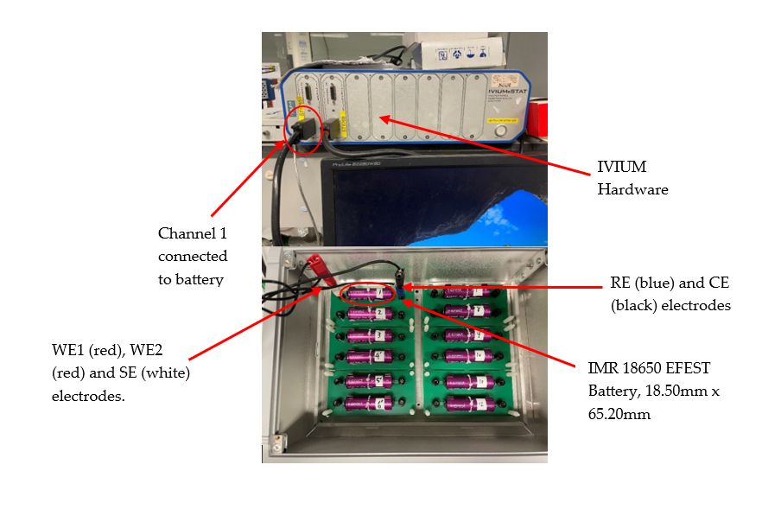
Figure 1. Experimental setup and electrode connections, WE (working electrode), SE (working sense electrode), RE (reference electrode) and CE (counter electrode). Cell holder mitigates vibrational and electromagnetic interference reducing noise.
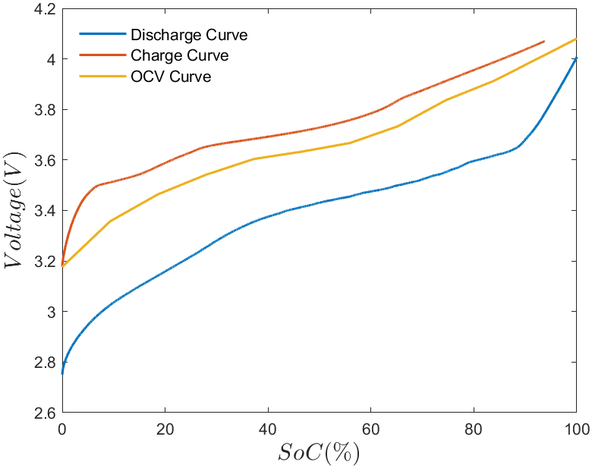 | 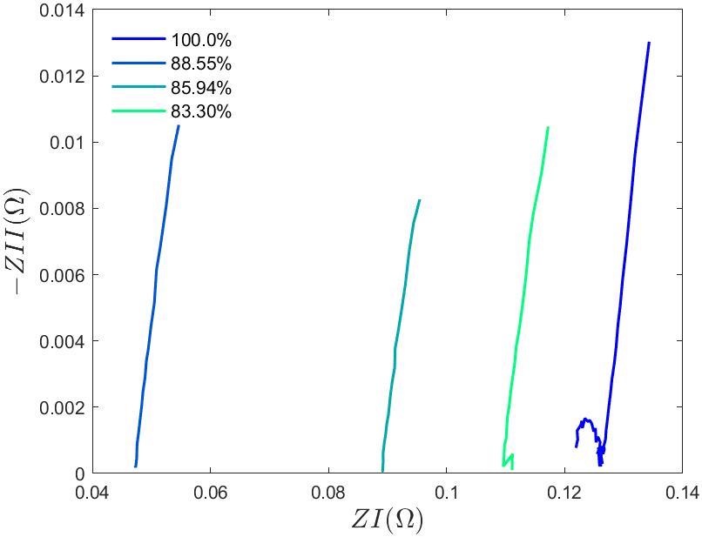
(a) | (b)
Figure 2. (a) Charge, discharge and OCV curve over SoC for healthy battery (100.0%); (b) Example EIS Nyquist plot against SoH for 70% SoC.

2.2. Distribution of Relaxation Time
An impedance function $Z\left(ω\right)$ is defined as in Eq. (3):
$$\begin{aligned}Z\left(ω\right)=Z^{'}\left(ω\right)+jZ^{''}\left(ω\right)\#\left(3\right)\end{aligned}$$
where $Z^{'}\left(ω\right)$ and $Z^{''}\left(ω\right)$ are the real and imaginary components of the impedance data at an angular frequency, $ω$, respectively. The DRT can be calculated by taking the impedance data in the frequency domain into the time domain. The data is represented by an infinite number of RC elements in series with a resistor; by solving this inverse problem the DRT function can be found. The form of this inverse problem is defined as follows in Eq. (4):
$$\begin{aligned}Z\left(ω\right)=R_{ohmic}+R_{pol}⋅\int_{0}^{∞}{\frac{γ\left(τ\right)}{1+jωτ}}dτ, γ\left(τ\right)≥0,\int_{0}^{∞}{γ(τ)dτ=1}\#\left(4\right)\end{aligned}$$
where $R_{ohmic}$ represents the internal resistance of the battery and $γ\left(τ\right)$ represents the distribution of relaxation times function, satisfying the condition of non-negativity and normalization:
$R_{pol}$ represents the total polarization resistance. The integrand $γ(τ)/(1+jωτ)$, also known as the kernel function, represents the contribution from each RC branch to the total polarization resistance [19].
Due to the ill-posed nature of the problem, discretization techniques are applied to solve the integral equation and estimate the DRT function resulting in the following expression Eq. (5):
$$\begin{aligned}Z\left(ω\right)=R_{ohmic}+R_{pol}⋅\sum_{k=1}^{n}{\frac{γ\left(τ_{k}\right)}{1+jωτ_{k}}}\#\left(5\right)\end{aligned}$$
The error introduced by discretisation can be mitigated through the introduction of radial basis functions (RBFs). The work of Wan et al. demonstrates that Gaussian RBFs converge faster and have greater validity over the domain when compared to other tested counterparts such as piece-wise linear RBFs [20]. The resulting linear inverse problem described in Eq. (6) is solved using optimization:
$$\begin{aligned}\min_{γ}{{\left\|Aγ-Z\right\|}_{2}^{2}}\#\left(6\right)\end{aligned}$$
where ${\left\|⋅⋅⋅\right\| }_{2}^{2}$ represents the square of the L2 norm of the vector $Aγ-Z$. $Z$ is the vector that represents the impedance data and $A$ is a matrix containing the contributions from the discretisation rule and the kernel function. To handle the intrinsically ill-posed nature of the problem, regularization is applied to avoid the creation of false peaks and oscillations in the solution. The most common technique used for lithium-ion batteries is Tikhonov regularisation which adds a penalty term leading to Eq. (7) [21]:
$$\begin{aligned}\min_{γ}{{\left\|Aγ-Z\right\|}_{2}^{2}}+λ⋅γ^{T}Mγ\#\left(7\right)\end{aligned}$$
where $λ$ is the regularization coefficient and $M$ denotes the regularisation matrix. The regularisation coefficient affects the balance between exactness in the output solution and stability. The L-curve criterion is used to find the parameter $λ$ where both the residual norm ${\left\|Aγ-Z\right\|}_{2}$ and the solution norm ${\left\|γ\right\|}_{2}$ are minimised. As in [22] the formulation for the regularization matrix $M$ achieves a penalty term that is proportional to the second derivative of $γ\left(τ\right)$.
This DRT formulation accurately describes systems that feature ohmic-capacitive effects without inductive behaviour, for this reason the high frequency behaviour of the spectrum which is typically found at frequencies greater than 1000 Hz must not be included [23] unless inductive elements are utilized [24].
To solve the inverse problem and produce the results in this paper, the open-source software developed in MATLAB by Ciucci et al. “DRTtools” was used [20], [22], [25], [26].

2.3. DRT Correlation to SoC
Each peak of the DRT attributed to an electrochemical process is affected differently by the SoC. Electric and magnetic effects active in the $τ<{10}^{-3}s$ region display very little dependence on SoC and show a small change with respect to temperature. SEI layer related effects have no direct link to SoC but display a shift to the right (larger time constant) and greater peak magnitude at lower temperature. Charge transfer and double layer effects typically produce two or more peaks which vary slightly with SoC. The peak associated with the cathode gives a higher response at lower SoCs while the peak associated with the anode displays a greater response at higher SoCs [19].
Diffusion-related processes with large time constants are greatly affected by the SoC and typically produce one peak with an increased magnitude when compared with the other processes. According to Ariyoshi et al. the diffusion coefficient reduces as the SoC reduces, resulting in an increase in Warburg impedance and shifting the corresponding Nyquist plot line to the low frequency side [27].

2.4. ECM Configuration
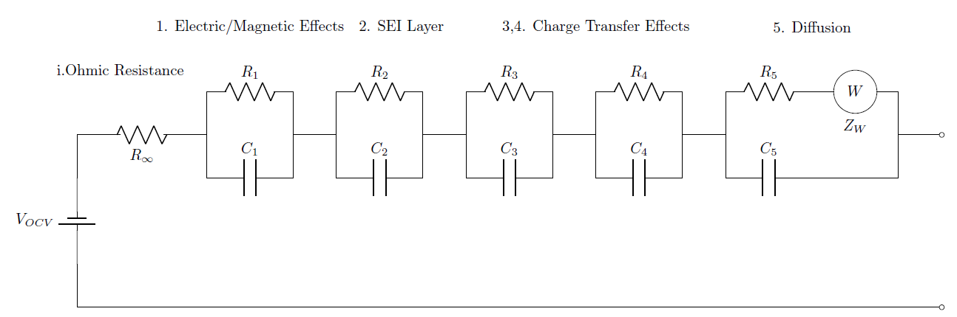
Figure 3. Equivalent circuit model used to describe electrochemical processes.
The DRT calculation can be used to deduce the form of the ECM, as shown in Figure 3, and utilized to model the electrochemical process of the battery. The DRT function displays a peak representing the system response at each characteristic time constant and is zero elsewhere in the domain. Each peak of the DRT can be attributed to a certain process and used to choose a component of the ECM. For the lithium-ion batteries tested, the proposed ECM consists of an internal (ohmic) resistance in series with RC components modelling, electric and magnetic effects, SEI effects and charge transfer. To aid modelling of the low frequency (diffusion) behaviour, a finite-length Warburg term is added to a RC branch to improve the accuracy of the ECM model [28]. The impedance of a single RC branch used to model electrochemical processes is given by Eq. (8):
$$\begin{aligned}Z_{i}=\frac{R_{i}}{1+jωR_{i}C_{ⅈ}}=\frac{R_{i}}{1+jωτ_{i}}\#(8)\end{aligned}$$
The contribution from the finite-length Warburg impedance is given by Eq. (9) [29]:
$$\begin{aligned}Z_{W}\left(ω\right)=\frac{R_{D}\tanh\left(\sqrt{jωR_{D}C_{D}}\right)}{\sqrt{jωR_{D}C_{D}}}=\frac{R_{D}\tanh\left(\sqrt{jωτ_{D}}\right)}{\sqrt{jωτ_{D}}}\#\left(9\right)\end{aligned}$$

3. Results

3.1. SOC and DRT
For each SoC the DRT was calculated using the optimum regularisation coefficient as determined by the L-curve criterion, $λ_{opt}=29.8×{10}^{-6}$, this was the largest value calculated among the SoCs tested. The DRT function at each SoH is presented in Figure 4 at five different SoCs.
A correlation between the SoC and diffusion of the battery is attempted through the DRT calculation. Two metrics are considered for this:
- The diffusion peak, representing the magnitude of the diffusion response.
- The time constant of the diffusion process.

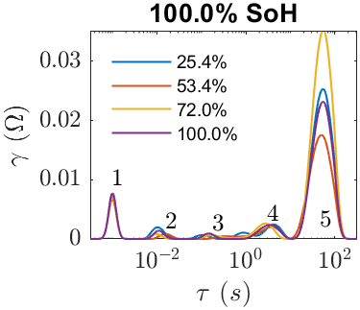 | 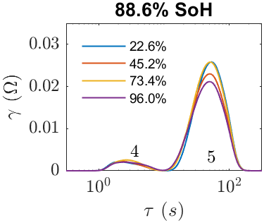
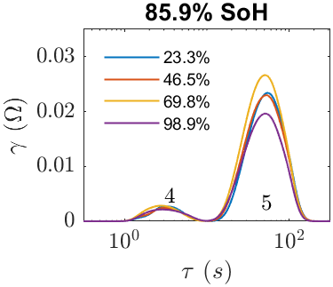 | 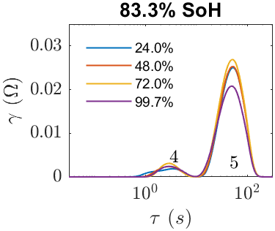
Figure 4. DRT plots for 100.0%, 88.6%, 85.9%, and 83.3% SoH, 4 SoCs shown.
Across all SoH, as depicted in Figure 4, peak 5 (diffusion) varies greatly with SoC. The DRT for a fully healthy cell (100% SoH) presents 5 peaks identified in Table 1, while at lower SoHs the DRT only contain two peaks. From Figure 5, the diffusion peak and the diffusion time constant decrease rapidly when the SoC increases for all SoH, particularly in the low SoC region (0-25% SoC); modelling this behaviour should therefore increase SoC estimation accuracy. However, above 60% SoC this relation becomes less evident. The diffusion peak dependency on both SoC and SoH should be modelled within an ECM, leading to greater estimation accuracy.
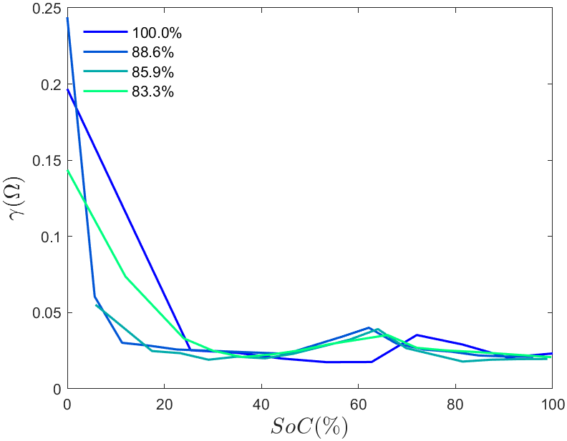 | 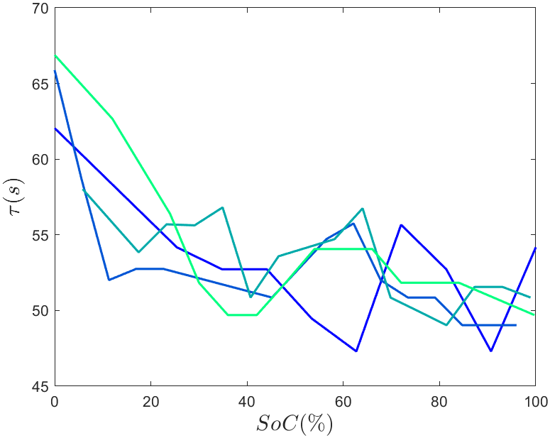
(a) | (b)
Figure 5. DRT correlation: (a) Diffusion time constant vs. SoC; (b) Diffusion peak vs. SoC.

3.1. Equivalent Circuit Model
The DRT results for all SoCs at 100.0% SoH feature 5 peaks that can be attributed to the following processes:
Table 1. Detected electrochemical processes from the DRT results in Figure 4, 5 peaks are detected for a healthy battery (100.0%), but only two peaks (4 and 5) for a degraded battery displayed in bold [19].
Peak | Time Constant ($τ$, s) | Description
1 | $$≈{10}^{-3}$$ | Electric/magnetic effects related peak
2 | $$≈{10}^{-2}$$ | SEI layer related peak
3 | $$≈{10}^{-1}$$ | Charge transfer peak 1
4 | $$≈4$$ | Charge transfer peak 2
5 | $$≈50$$ | Diffusion peak
Based on the information uncovered by the DRT summarised in Table. 1, the proposed ECM is composed of the following components:
- An internal resistance modelled by the ohmic resistance $R_{∞}$.
- 4 RC branches to model electric/magnetic effects, SEI-related effects, and the two peaks associated with charge transfer.
- 1 RC branch component in conjunction with the semi-infinite Warburg term to model diffusion.
The total impedance of the proposed ECM model in Figure 3 is given by the following expression (10):
$$\begin{aligned}Z_{ecm}=R_{∞}+\sum_{1}^{4}{\frac{R_{i}}{1-jωR_{i}C_{ⅈ}}}+\frac{jωC_{5}\left(R_{5}\sqrt{jωR_{5}C_{5}}+R_{D}\tanh\left(\sqrt{jωR_{5}C_{5}}\right)\right)}{\sqrt{jωR_{5}C_{5}}\left(R_{5}+jωC_{5}\right)+R_{D}\tanh\left(\sqrt{jωR_{5}C_{5}}\right)}\#\left(10\right)\end{aligned}$$
The collected EIS data is matched to the ECM model by formulating the optimisation problem described in (11) and solved using MATLAB’s optimisation toolbox. The problem consists of finding the estimated parameters that simultaneously minimise the residuals between the real and imaginary components of the data and the estimated model impedance. To fit the complex data the non-linear least squares algorithm, lsqnonlin is used.
$$\begin{aligned}\underset{x}{minimise}{\sum_{f=f_{start}}^{f_{end}}{\left(Z_{ecm}\left(x\right)-Z_{EIS}\right)}}\#\left(11\right)\end{aligned}$$
where $x$ is a vector containing the parameters to be estimated and fitted to the model, for the ECM proposed it has the following form in (12):
$$\begin{aligned}x=\left[R_{∞ }R_{1 }R_{2 }R_{3 }R_{4 }R_{5 }C_{1 }C_{2 }C_{3 }C_{4 }C_{5 }R_{D}C_{D}\right]\#\left(12\right)\end{aligned}$$

3.3. OCV Estimation
Once offline, the terminal voltage of the battery will be affected by capacitive effects over time until the OCV is reached. The OCV can be estimated by assuming a steady-state where the contributions to the OCV come purely from the resistances of each branch and the internal resistance. This leads to (13) below which can be used to estimate the OCV.
$$\begin{aligned}V_{OCV}≈V_{t}+i\left(R_{∞}+\sum_{j=1}^{n}{R_{j}}\right)≈V_{t}+i\left(R_{∞}+R_{1}+R_{2}+R_{3}+R_{4}+R_{5}+R_{D}\right)\#\left(13\right)\end{aligned}$$
where $V_{t}$ is the terminal voltage, $n$ is the number of RC branches, including the diffusion branch and internal resistance with $R_{j}$ being the resistance contribution from each branch and $i$ is the current used during charging (negative) or discharging (positive), for this step $i=210 mA$. Figure 6 displays an example ECM fit for both models and resulting OCV-SoC curve.
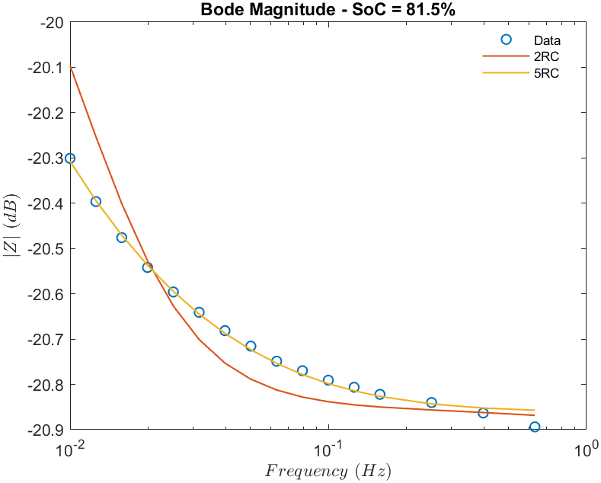 | 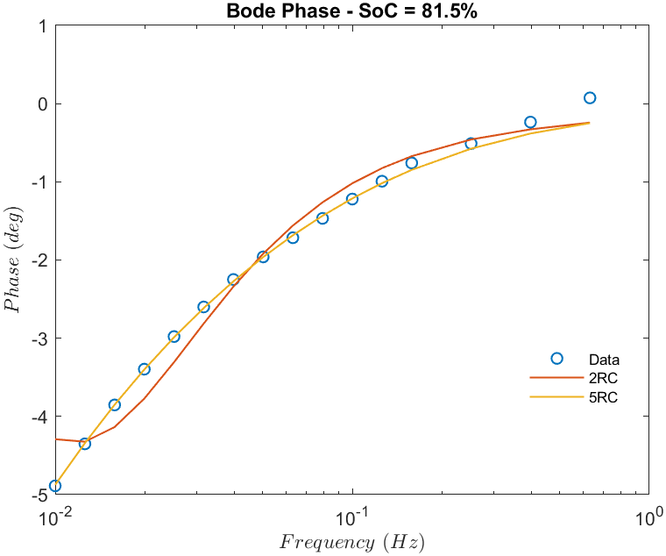
(a) | (b)
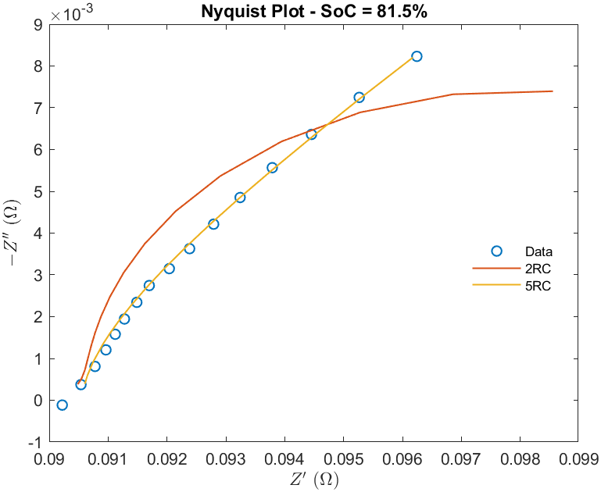 | 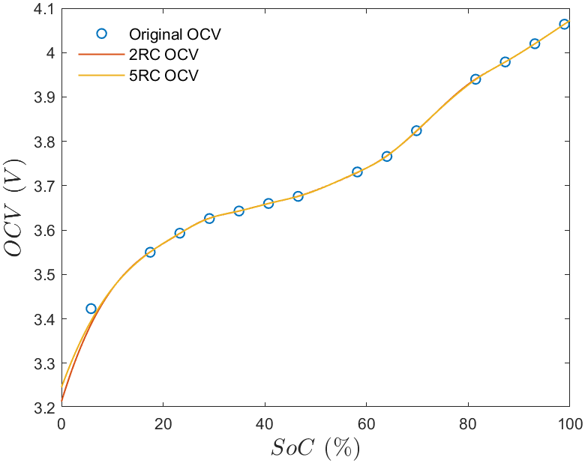
(c) | (d)
Figure 6. ECM fit example for 81.5% SoC, 85.9% SoH, and resulting OCV characteristics: (a) Bode plot (magnitude); (b) Bode plot (phase); (c) Nyquist plot; (d) OCV-SoC curve.
As demonstrated by Figure 6, the 5RC model better captures the impedance, particularly in the low frequency region, with the OCV-SoC curve better following the original at low SoC. For each case the ECM is fitted, and the SoC interpolated from the OCV-SoC curve. Tables 2-5 display the results for each cell.

Table 2. Results and comparison between proposed and standard 2RC branch ECM for 100.0% SoH cell. Average difference; 5RC – 2.21%; 2RC – 5.65%.
SoC (%) | ECM (5RC) | Difference (%) | ECM (2RC) | Difference (%)
100 | 100.133 | 0.133 | 100.686 | 0.686
90.7 | 90.098 | -0.664 | 88.633 | -2.279
81.4 | 80.835 | -0.695 | 79.297 | -2.583
72.0 | 71.314 | -0.953 | 69.371 | -3.651
62.7 | 61.494 | -1.923 | 59.048 | -5.825
53.4 | 50.116 | -6.150 | 46.856 | -12.255
44.1 | 41.441 | -6.029 | 39.444 | -10.557
34.8 | 34.520 | -0.805 | 33.136 | -4.781
25.4 | 24.750 | -2.558 | 23.306 | -8.244
Table 3. Results and comparison between proposed and standard 2RC branch ECM for 88.6% SoH cell. Average difference; 5RC – 0.59%; 2RC – 5.98%.
SoC (%) | ECM (5RC) | Difference (%) | ECM (2RC) | Difference (%)
96.00 | 95.668 | -0.346 | 94.890 | -1.157
90.35 | 90.012 | -0.375 | 89.225 | -1.245
84.71 | 84.390 | -0.378 | 83.561 | -1.356
79.06 | 78.984 | -0.096 | 78.034 | -1.298
73.41 | 73.381 | -0.039 | 72.338 | -1.460
67.76 | 67.613 | -0.217 | 66.604 | -1.706
62.12 | 62.212 | 0.147 | 60.882 | -1.993
56.47 | 56.330 | -0.248 | 54.758 | -3.032
45.17 | 44.575 | -1.317 | 43.376 | -3.972
22.59 | 22.429 | -0.712 | 21.356 | -5.462
16.94 | 16.868 | -0.425 | 15.567 | -8.104
11.29 | 11.152 | -1.221 | 9.824 | -12.987
5.65 | 5.528 | -2.153 | 7.567 | 33.924
Table 4. Results and comparison between proposed and standard 2RC branch ECM for 85.9% SoH cell. Average difference; 5RC – 1.05%; 2RC – 4.05%.
SoC (%) | ECM (5RC) | Difference (%) | ECM (2RC) | Difference (%)
98.91 | 98.394 | -0.522 | 97.616 | -1.309
93.09 | 92.671 | -0.450 | 91.877 | -1.303
87.25 | 86.961 | -0.354 | 86.087 | -1.356
81.45 | 81.086 | -0.447 | 80.384 | -1.308
69.81 | 69.721 | -0.127 | 69.128 | -0.976
64.00 | 64.064 | 0.099 | 62.335 | -2.602
58.18 | 57.772 | -0.702 | 56.281 | -3.264
46.54 | 45.838 | -1.510 | 43.412 | -6.722
40.72 | 40.045 | -1.658 | 38.062 | -6.527
34.91 | 35.016 | 0.303 | 32.520 | -6.847
29.09 | 31.167 | 7.139 | 27.166 | -6.615
23.27 | 23.228 | -0.181 | 22.312 | -4.115
17.45 | 17.295 | -0.887 | 16.261 | -6.813
5.82 | 5.840 | 0.348 | 6.224 | 6.936
Table 5. Results and comparison between proposed and standard 2RC branch ECM for 85.9% SoH cell. Average difference; 5RC – 2.46%; 2RC – 8.15%.
SoC (%) | ECM (5RC) | Difference (%) | ECM (2RC) | Difference (%)
99.720 | 92.450 | -7.291 | 107.503 | 7.804
84.010 | 83.991 | -0.023 | 86.020 | 2.393
78.010 | 78.019 | 0.012 | 78.130 | 0.153
72.010 | 72.793 | 1.087 | 73.970 | 2.722
66.010 | 66.916 | 1.372 | 69.473 | 5.246
54.010 | 55.410 | 2.592 | 59.868 | 10.847
48.010 | 48.157 | 0.307 | 49.537 | 3.180
42.010 | 42.049 | 0.092 | 42.624 | 1.461
36.010 | 36.149 | 0.387 | 37.740 | 4.805
24.000 | 24.211 | 0.878 | 26.512 | 10.465
12.000 | 12.644 | 5.365 | 14.375 | 19.790
6.000 | 5.390 | -10.169 | 4.262 | -28.960
For all cases the DRT informed ECM with the inclusion of the diffusion term results in greatly improved performance as noted by the mean percentage difference. This is especially seen at lower SoCs and SoHs where the traditional 2RC ECM becomes progressively worse, despite the DRT for lower SoHs only displaying two peaks; improvement from 5.648% to 2.212% in the 100% SoH case, and 8.1521% to 2.464% in the 83.30% SoH case. Additionally, the model is significantly more accurate in the low SoC region (0-25%) when compared to the 2RC model.

4. Discussion
This study investigated the feasibility of correlating impedance-derived features to state of charge, evaluating the strengths and limitations of both DRT-based feature extraction and guided ECM modelling methods.

4.1. DRT Correlation to SoC
Consistent with [19] it was found that the diffusion peak shows the most dependence on the SoC, as the SoC increased from 0% both the diffusion peak and time constant decreased monotonically, implying an increase in diffusion coefficient [27]. However, beyond approximately 60% SoC this relation breaks and neither the diffusion peak magnitude nor the time constant continued to decrease consistently towards 100% SoC suggesting a change in diffusion dynamics. In combination with the online EIS methods reported in [13] and [14] this work suggests that diffusion-related DRT features could potentially be employed in real-time SoC estimation, provided valid EIS data is acquired, and computational feasibility. This approach would resemble an OCV-based lookup method where diffusion peak characteristic or time constants are mapped directly to SoC values allowing the model to be deployed in real-time. Sensitivity to measurement noise and temperature variation must be addressed for reliable implementation in a battery management system. As discussed in [19] the peak corresponding to SEI related effects saw a smaller dependence on SoC in contrast with the diffusion peak. Further research into the sensitivity of this peak may provide additional information for SoC estimation.

4.2. ECM Fitting and SoC Estimation
The ECM proposed in [10] was extended to contain diffusion-related elements and specifically chosen RC elements identified through the DRT. The proposed diffusion element involving a finite-length Warburg term was able to accurately reproduce the low frequency response. In terms of SoC estimation performance, the model was able to reliably predict the SoC, showing a strong improvement in the low SoCs (0-25%), particularly at low SoHs when compared to the 2RC model, delivering an average difference of 0.59% with the greatest difference being 2.46% for the 5RC model. In all SoH cases ECMs struggled to estimate decreasing SoCs as noted by the generally increasing error as SoC decreased. These deviations may be attributed to non-linear electrochemical behaviour particularly at lower SoCs and sensitivity to selected model parameters in these regions [30].

4.3. Future Work
While the findings demonstrate the promise of DRT‑enhanced impedance analysis for SoC estimation, several avenues remain for further investigation. The trends identified in EFEST 18650 cells should be validated using other lithium‑ion chemistries (e.g., NMC, LFP, NCA) and cell formats such as pouch or prismatic cells. Diffusion‑related DRT features may behave differently depending on electrode composition, porosity, and manufacturing variations.
Both the diffusion peak and diffusion time constant exhibited consistent trends only up to ~60% SoC. Future work could explore the electrochemical mechanisms responsible for the reduced sensitivity at higher SoC, potentially by combining DRT with in‑situ diagnostics (e.g., differential capacity analysis, incremental OCV).
Since diffusion processes are highly temperature sensitive, extending the analysis to multiple temperatures may allow the development of a temperature‑compensated DRT‑based SoC estimator, increasing robustness for real‑world applications.
The DRT‑guided ECM developed in this study performed well for OCV‑based estimation. Expanding this into hybrid ECM/physics‑based models including constant phase elements [30] or integrating DRT‑derived diffusion parameters directly into reduced‑order models may improve SoC estimation under dynamic loads.
Because diffusion parameters also evolve with ageing, future work could assess whether the same DRT features can be used simultaneously for SoC and SoH estimation, potentially leading to unified impedance‑based battery diagnostics.
Traditional EIS measurements can be slow.

5. Conclusions
This study demonstrates the potential of EIS combined with the DRT method as a viable approach for estimating the State of Charge (SoC) of lithium‑ion cells. Analysis of EFEST 18650 cells revealed a clear dependence of the DRT diffusion peak and diffusion time constant on SoC, with both metrics decreasing consistently as SoC increased up to approximately 60%. This behaviour confirms the sensitivity of diffusion‑related electrochemical processes to changes in SoC and highlights the usefulness of DRT‑derived parameters as diagnostic indicators.
Beyond identifying these correlations, the work also leveraged DRT insights to guide the selection of an appropriate equivalent circuit model (ECM) incorporating diffusion elements. The resulting OCV‑based SoC estimation method achieved strong accuracy, with predictions differing from reference values by as little as 0.012% and never exceeding 10.2%. These results validate the suitability of integrating DRT analysis and diffusion elements into model‑based SoC estimation frameworks.
Overall, the findings indicate that DRT‑enhanced impedance analysis can provide valuable information for SoC estimation and may serve as a foundation for improved battery monitoring strategies, particularly where high accuracy and sensitivity to diffusion processes are required.
Author Contributions: Conceptualization, S.M.S.; methodology, S.M.S and M.F.; software, M.F..; validation, M.F..; formal analysis, M.F..; investigation, M.F..; resources, S.M.S.; data curation, M.F..; writing—original draft preparation, M.F..; writing—review and editing, S.M.S., G.O., and S.M.S..; visualization, M.F.; supervision, S.M.S.; project administration, S.M.S.; funding acquisition, S.M.S. All authors have read and agreed to the published version of the manuscript.”
Funding: This research was partly funded by the Future Electric Vehicle Energy Networks supporting Renewables (FEVER) grant EP/W005883/1.
Data Availability Statement: Data and analysis code are available at https://github.com/Miguel-Ferreira-hub/Individual-Project.
Acknowledgments: Project consumables costs were provided by the Department of Mechanical Engineering. University of Southampton and the FEVER grant.
Conflicts of Interest: The authors declare no conflicts of interest.

Abbreviations
The following abbreviations are used in this manuscript:
BMS | Battery Management System
DRT | Distribution of Relaxation Times
EIS | Electrochemical Impedance Spectroscopy
ECM | Equivalent Circuit Model
SoC | State of Charge
SoH | State of Health

References
- M. Danko, J. Adamec, M. Taraba, and P. Drgona, “Overview of batteries State of Charge estimation methods,” Transportation Research Procedia, vol. 40, pp. 186–192, 2019, doi: 10.1016/j.trpro.2019.07.029.
- G. L. Plett, “Extended Kalman filtering for battery management systems of LiPB-based HEV battery packs,” Journal of Power Sources, vol. 134, no. 2, pp. 252–261, Aug. 2004, doi: 10.1016/j.jpowsour.2004.02.031.
- G. L. Plett, “Extended Kalman filtering for battery management systems of LiPB-based HEV battery packs,” Journal of Power Sources, vol. 134, no. 2, pp. 262–276, Aug. 2004, doi: 10.1016/j.jpowsour.2004.02.032.
- G. L. Plett, “Extended Kalman filtering for battery management systems of LiPB-based HEV battery packs,” Journal of Power Sources, vol. 134, no. 2, pp. 277–292, Aug. 2004, doi: 10.1016/j.jpowsour.2004.02.033.
- H. Chao, B. D. Youn, and J. Chung, “A multiscale framework with extended Kalman filter for lithium-ion battery SOC and capacity estimation,” Applied Energy, vol. 92, pp. 694–704, Apr. 2012, doi: 10.1016/j.apenergy.2011.08.002.
- C. Campestrini, T. Heil, S. Kosch, and A. Jossen, “A comparative study and review of different Kalman filters by applying an enhanced validation method,” Journal of Energy Storage, vol. 8, pp. 142–159, Nov. 2016, doi: 10.1016/j.est.2016.10.004.
- M. Messing, T. Shoa, R. Ahmed, and S. Habibi, “Battery SoC Estimation from EIS using Neural Nets,” pp. 588–593, Jun. 2020, doi: https://doi.org/10.1109/itec48692.2020.9161523.
- F. Yang, S. Zhang, W. Li, and M. Qiang, “State-of-charge estimation of lithium-ion batteries using LSTM and UKF,” Energy, vol. 201, p. 117664, June 2020, doi: 10.1016/j.energy.2020.117664.
- R. Xiong, J. Cao, Q. Yu, H. He and F. Sun, "Critical Review on the Battery State of Charge Estimation Methods for Electric Vehicles," in IEEE Access, vol. 6, pp. 1832-1843, 2018, doi: 10.1109/ACCESS.2017.2780258.
- Z. Pang, K. Yang, Z. Song, G. Chen, and P. Niu, “Research on SOC Estimation of Lithium Battery Based on Electrochemical Impedance Spectroscopy,” 2022 5th International Conference on Energy, Electrical and Power Engineering (CEEPE), pp. 1638–1643, May 2023, doi: https://doi.org/10.1109/ceepe58418.2023.10166963.
- J. Estaller, A. Kersten, M. Kuder, T. Thiringer, R. Eckerle, and T. Weyh, “Overview of Battery Impedance Modeling Including Detailed State-of-the-Art Cylindrical 18650 Lithium-Ion Battery Cell Comparisons,” Energies, vol. 15, no. 10, p. 3822, May 2022, doi: https://doi.org/10.3390/en15103822.
- P. Iurilli, N. Koch, R. E. Carrillo and C. Brivio, "DRT-based SoC estimation for commercial Li-ion battery pack," 2023 International Conference on Clean Electrical Power (ICCEP), Terrasini, Italy, 2023
- K. Liu, G. I. Orfanoudakis, S. M. Sharkh and A. J. Cruden, "Online Battery Pack Electrochemical Impedance Spectroscopy Measurement Using a Three-Phase Neutral Point Clamped Converter," 2023 International Conference on Clean Electrical Power (ICCEP), Terrasini, Italy, 2023, pp. 63-69, doi: 10.1109/ICCEP57914.2023.10247461.
- H. D. Wahyudi, K. Liu, R. Yang, G. I. Orfanoudakis, R. Wills, A. Cruden, S. M. Sharkh, “Online Battery EIS using Cell Voltage Balancing Circuit and PRBS Excitation” UK Energy Storage (UKES) 2025 Conference, Sheffield, UK, 14-17 April 2025.
- “State of Charge - an overview | ScienceDirect Topics,” www.sciencedirect.com. https://www.sciencedirect.com/topics/engineering/state-of-charge (accessed Sept. 03, 2026).
- “Test of Efest IMR18650 3500mAh (Purple) 2017,” Lygte-info.dk, 2017. https://lygte-info.dk/review/batteries2012/Efest%20IMR18650%203500mAh%20(Purple)%202017%20UK.html (accessed Sept. 03, 2026).
- F. Zhang, Z. Xing, and M. Wu, “State of health estimation for Li-ion battery using characteristic voltage intervals and genetic algorithm optimized back propagation neural network,” Journal of Energy Storage, vol. 57, p. 106277, Jan. 2023, doi: 10.1016/j.est.2022.106277.
- “Efest IMR 18650 2100mAh 38A flat top battery - Batteries - EFEST® Battery and Charger Manufacturer,” Efestpower.com, 2026. https://www.efestpower.com/index.php?ac=article&at=read&did=393 (accessed Sept. 03, 2026).
- P. Iurilli, C. Brivio, R. E. Carrillo and V. Wood, "EIS2MOD: A DRT-Based Modeling Framework for Li-Ion Cells," in IEEE Transactions on Industry Applications, vol. 58, no. 2, pp. 1429-1439, March-April 2022
- Wan, T. H., Saccoccio, M., Chen, C., & Ciucci, F. (2015). Influence of the discretization methods on the distribution of relaxation times deconvolution: implementing radial basis functions with DRTtools. Electrochimica Acta, 184, 483-499.
- Yuan, D., Zhang, X. An overview of numerical methods for the first kind Fredholm integral equation. SN Appl. Sci. 1, 1178 (2019).
- M. Saccoccio, T. H. Wan, C. Chen, and F. Ciucci, “Optimal Regularization in Distribution of Relaxation Times applied to Electrochemical Impedance Spectroscopy: Ridge and Lasso Regression Methods - A Theoretical and Experimental Study,” Electrochimica Acta, vol. 147, pp. 470–482, Nov. 2014, doi:
- N. Meddings et al., “Application of electrochemical impedance spectroscopy to commercial Li-ion cells: A review,” Journal of Power Sources, vol. 480, p. 228742, Dec. 2020, doi: https://doi.org/10.1016/j.jpowsour.2020.228742.
- F. Ciucci, “Modeling electrochemical impedance spectroscopy,” Current Opinion in Electrochemistry, vol. 13, pp. 132–139, Feb. 2019, doi: https://doi.org/10.1016/j.coelec.2018.12.003.
- Liu, J., Wan, T. H., & Ciucci, F. (2020).A Bayesian view on the Hilbert transform and the Kramers-Kronig transform of electrochemical impedance data: Probabilistic estimates and quality scores. Electrochimica Acta, 357, 136864.
- ciuccislab, “GitHub - ciuccislab/DRTtools: An intuitive MATLAB GUI to compute the DRT,” GitHub, 2025. https://github.com/ciuccislab/DRTtools (accessed Sept. 03, 2026).
- K. Ariyoshi, Z. Siroma, A. Mineshige, M. Takeno, T. Fukutsuka, T. Abe, S Uchida, “Electrochemical impedance spectroscopy Past 1: Fundamentals”, Electrochemistry, Vol. 90, No. 10, p. 102007.
- Y. Inui, S. Hirayama, and T. Tanaka, “Investigation of time domain measurement of electrochemical impedance spectrum in low frequency range for lithium-ion batteries using preset equivalent circuit model,” Journal of Electroanalytical Chemistry, vol. 950, p. 117894, Oct. 2023, doi: 10.1016/j.jelechem.2023.117894.
- Moya, A.A, “Low-frequency development approximations to the transmissive Warburg diffusion impedance,” Journal of Energy Storage, vol. 55, p. 105632, Nov. 2022, doi: 10.1016/j.est.2022.105632.
- “Basics of EIS: Electrochemical Research-Impedance,” www.gamry.com. https://www.gamry.com/application-notes/EIS/basics-of-electrochemical-impedance-spectroscopy/

Disclaimer/Publisher’s Note: The statements, opinions and data contained in all publications are solely those of the individual author(s) and contributor(s) and not of MDPI and/or the editor(s). MDPI and/or the editor(s) disclaim responsibility for any injury to people or property resulting from any ideas, methods, instructions or products referred to in the content.

